***David Gray x13467362 Software Engineering***

**System and Unit Testing for the Game Rental System (GRS):**

**System Testing**

***Test Plans:***

There are 5 total processes in the GRS. Testing these processes is vital to the functionality of the system as a whole.

* **Enter Password:** The user of the system, the cashier in this case, will input the password for the GRS. The user will set the password and have to validate it by entering it again. If a wrong answer is given the system will display an error message and the whole system will have to be restarted.
* **Enter Member ID:** The member ID is unique to each member of the Game Rental store. This ID will help identify which member has which game, for how long, and if they have any overdue fees. If an invalid ID is entered the system will display an Error message and the user will need to re-input a valid member ID.
* **Enter Game Title:** The game title is unique to every game. The user will input the name of the game into the GRS. If the game entered is invalid the system will display an error message and a valid game title must be entered to continue to the next process.
* **Enter Platform:** After the title of the game is input into the system the next stage is to choose a platform. This process is very important because it contributes to the total cost due to the fact that a PS3 game < PS4 in value for example. The same goes for Xbox 360 and Xbox One games. If an invalid platform is entered the system will alert the user with an error message and a correct platform must be entered to move on.
* **Check Inventory:** The system will automatically check if the desired game title and platform is available. If it is available the user can then input the length of the rental, if not available they system will take the user back to the Enter Game title process to start the process again.
* **Length of Rental:** This process consists of inputting the desired length the customer wants to rent the game for. There are only two options for this process: either one week or two weeks. This option was added to the process to simplify the Calculate Total Cost process. If 3 weeks is entered for example the system will not let the user continue until this is rectified.
* **Calculate Total Cost:** All the data from the previous 4 processes are necessary to complete this process. The system will add the price of the desired game, the platform and the length of the rental to output the total cost of the transaction. All of the transaction details like the rental information and sale information are then stored in their relative data stores.
* **Transaction report:** Once all the processes have completed successfully the system will display a transaction report for the user and print the same report for the customer.

**Component Testing:**

**Prototype test:**

The prototype was made, compiled and tested using Java and TextPad.

For the GRS I decided to make my prototype based on the **Enter password** process. The user has to enter their name, for reference purposes if needs be, then the first time they enter their password, the system sets whatever they input into the system. Then they must validate their password by entering it again. If the user inputs the wrong password for the validation process an error message will display and the system will have to be restarted.

**Restrictions:**

1. They password process will not accept a password shorter than 6 or longer than 10 characters.

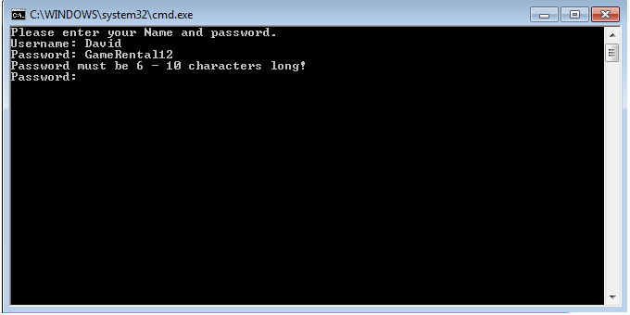

1. It will not accept any numerical values. If a number is entered the system will display and error message and will have to be restarted.

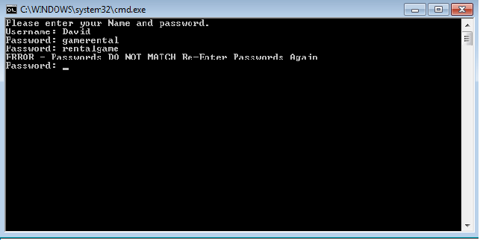

**Cyclomatic complexity workings:**

The work out the cyclomatic complexity I used two formulas.

1. V(G) = E – N + 2 || V(G) = 9 – 9 + 2 = 2

E = Edges

N = Nodes

1. V(G) = P + 1 || V(G) = 1 + 1 = 2

P = Predicate nodes

I based my workings on the System Architecture diagram shown below

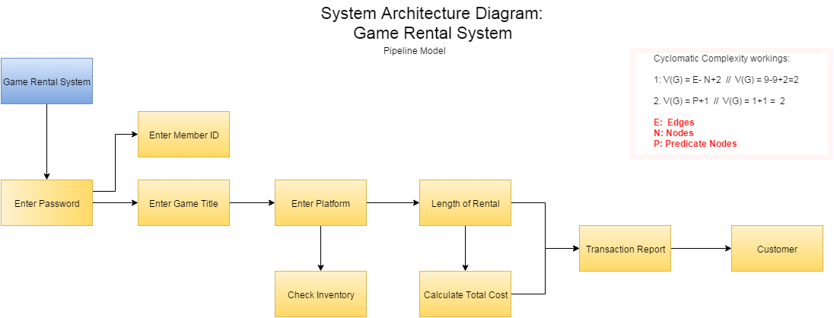

**Structure Diagram: Based on Level 2 DFD for Calculating Total Cost:**

This structure diagram shows the flow of data, commands and choices the system has to make. From the game title, game platform and length of rental the systems user can only choose one option for each of the processes.

